PYTHON PROGRAMMING ABL

Case Studies 11–20
Student Name: BOPPANA JYOTIRADITYA
Roll Number: 26000013
Branch: CSE | Section: CSE-1
Ten additional beginner-level Python case studies. Add genuine output screenshots before final submission.
Case Study 11: Electricity Bill Calculator
1. Problem Statement
Read electricity units and calculate a bill: first 100 units at 2 each, next 100 at 3 each, and remaining units at 5 each.

2. Algorithm
- Read units.
- Reject negative units.
- Apply the correct rate slabs.
- Display the bill.

3. Flowchart
Start
|
Read input
|
Process data
|
Display output
|
Stop

4. Pseudocode
START
INPUT required data
PROCESS using conditions / loop
DISPLAY result
STOP

5. Python Source Code
units = int(input("Enter units consumed: ")) if units < 0:
print("Invalid units") elif units <= 100: bill = units * 2 print("Electricity bill: Rs.", bill) elif units <= 200:
bill = 200 + (units - 100) * 3
print("Electricity bill: Rs.", bill) else:
bill = 500 + (units - 200) * 5 print("Electricity bill: Rs.", bill)

6. Sample Input and Output
Input: 50
Expected result: Rs. 100

7. Test Cases
Input: 50 — Expected: Rs. 100
Input: 150 — Expected: Rs. 350
Input: 250 — Expected: Rs. 750
- Output Screenshot
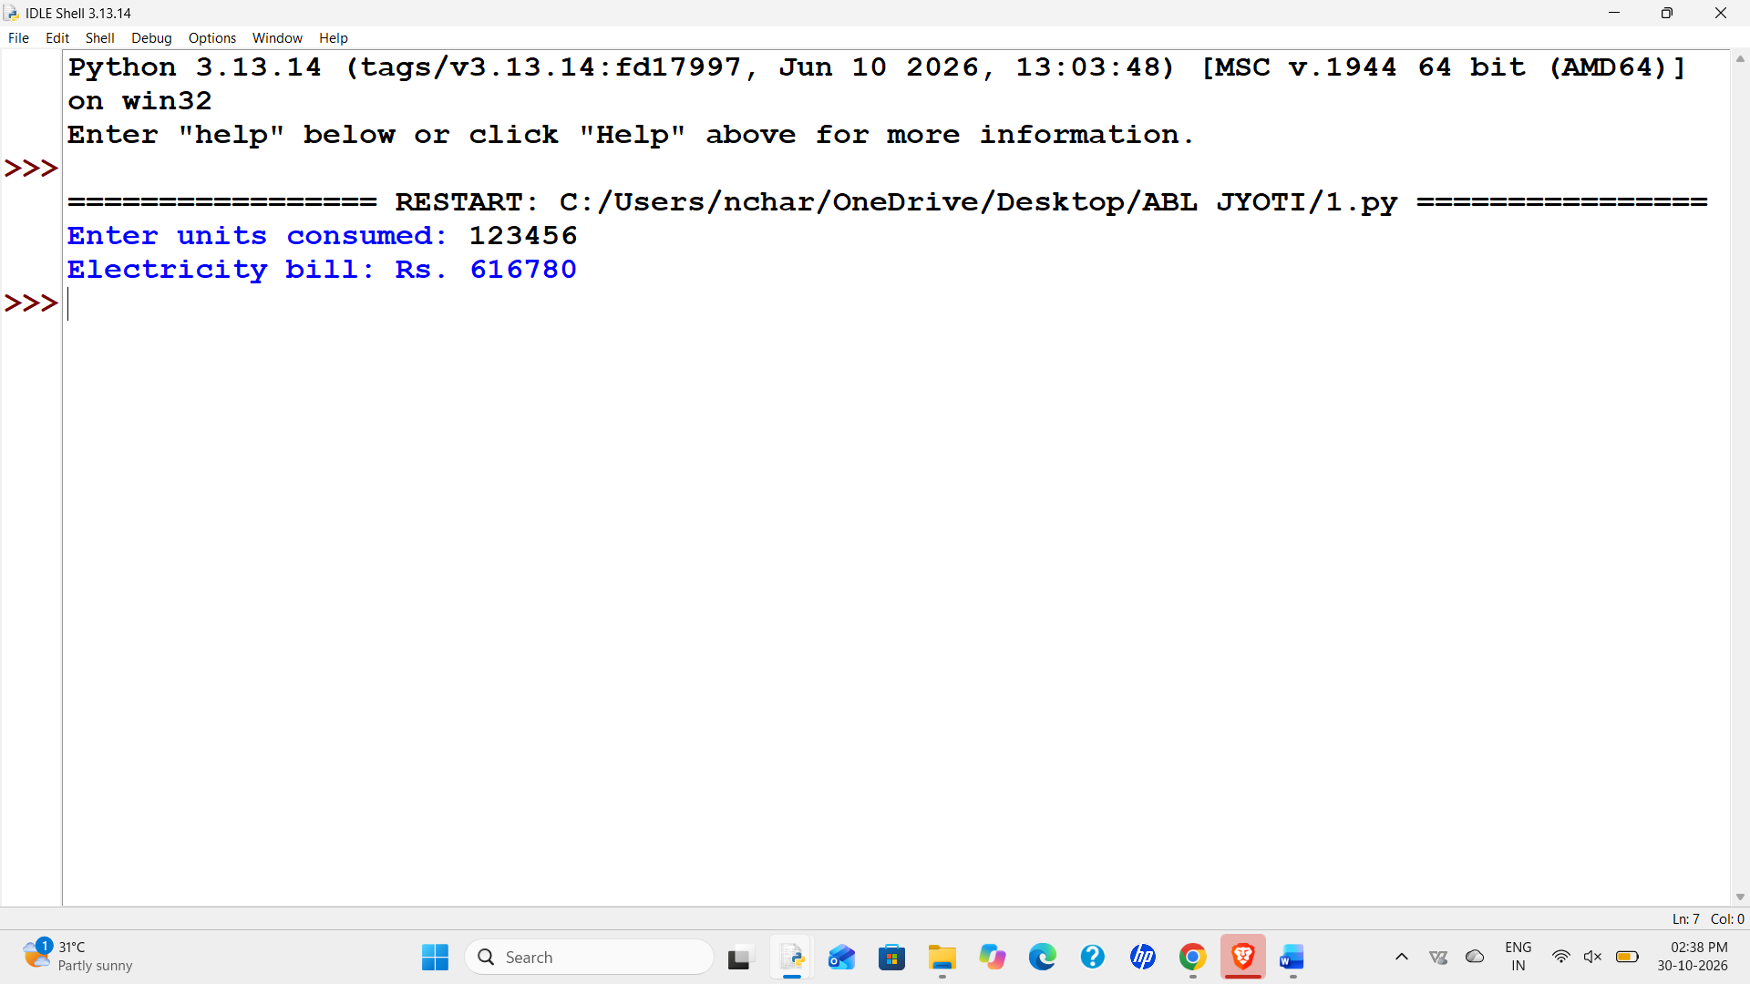
- Conclusion
The program calculates an electricity bill using slab rates.

Case Study 12: Shopping Discount Calculator
1. Problem Statement
Read a shopping amount and apply a 10% discount when the amount is 1000 or more.

2. Algorithm
- Read the amount.
- Reject a negative amount.
- Apply 10% discount for amounts at least 1000.
- Display discount and final amount.

3. Flowchart
Start
|
Read input
|
Process data
|
Display output
|
Stop

4. Pseudocode
START
INPUT required data
PROCESS using conditions / loop
DISPLAY result
STOP

5. Python Source Code
amount = float(input("Enter shopping amount: ")) if amount < 0:
print("Invalid amount") else: if amount >= 1000:
discount = amount * 0.10 else:
discount = 0 total = amount - discount print("Discount: Rs.", round(discount, 2)) print("Final amount: Rs.", round(total, 2))

6. Sample Input and Output
Input: 1500
Expected result: Discount Rs. 150.0; Final Rs. 1350.0

7. Test Cases
Input: 1500 — Expected: Discount Rs. 150.0; Final Rs. 1350.0
Input: 800 — Expected: Discount Rs. 0; Final Rs. 800.0
Input: 0 — Expected: Discount Rs. 0; Final Rs. 0.0
- Output Screenshot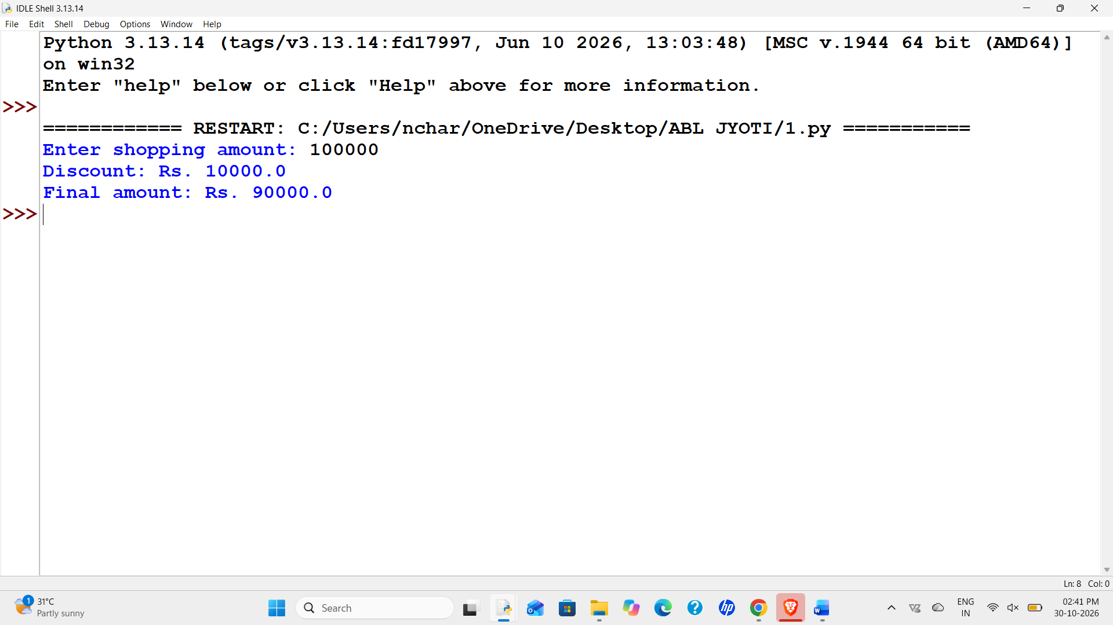
- Conclusion
The program uses conditions to calculate a discount.

Case Study 13: Word and Character Counter
1. Problem Statement
Accept a sentence and count its characters (excluding outside spaces) and words.

2. Algorithm
- Read a sentence.
- Remove leading and trailing spaces.
- Count characters.
- Split and count words.
- Display both counts.

3. Flowchart
Start
|
Read input
|
Process data
|
Display output
|
Stop

4. Pseudocode
START
INPUT required data
PROCESS using conditions / loop
DISPLAY result
STOP

5. Python Source Code
sentence = input("Enter a sentence: ") clean_sentence = sentence.strip() words = clean_sentence.split() print("Character count:", len(clean_sentence)) print("Word count:", len(words))

6. Sample Input and Output
Input: Python is easy
Expected result: Characters: 14; Words: 3

7. Test Cases
Input: Python is easy — Expected: Characters: 14; Words: 3
Input: Hello — Expected: Characters: 5; Words: 1
Input: — Expected: Characters: 0; Words: 0
- Output Screenshot
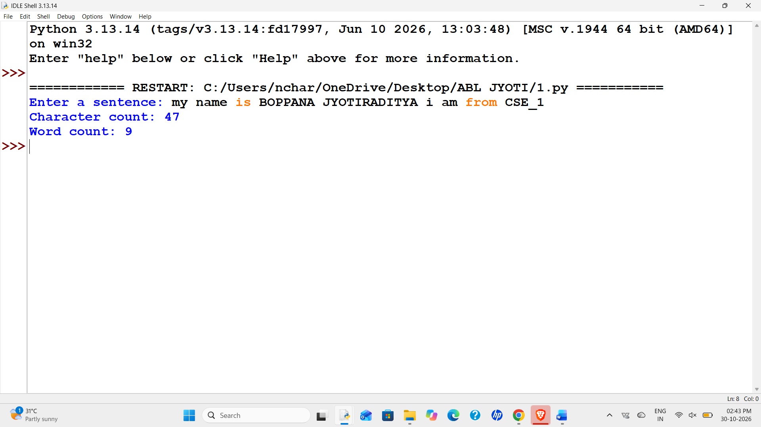
- Conclusion
The program practices string methods and built-in functions.

Case Study 14: Prime Number Checker
1. Problem Statement
Check whether an integer is a prime number.

2. Algorithm
- Read an integer.
- Numbers below 2 are not prime.
- Check possible divisors using a loop.
- Display the result.

3. Flowchart
Start
|
Read input
|
Process data
|
Display output
|
Stop

4. Pseudocode
START
INPUT required data
PROCESS using conditions / loop
DISPLAY result
STOP

5. Python Source Code
n = int(input("Enter an integer: ")) if n < 2:
print(n, "is not a prime number") else:
prime = True for i in range(2, n): if i * i > n: break if n % i == 0: prime = False break if prime:
print(n, "is a prime number") else: print(n, "is not a prime number")

6. Sample Input and Output
Input: 7
Expected result: 7 is a prime number

7. Test Cases
Input: 7 — Expected: 7 is a prime number
Input: 12 — Expected: 12 is not a prime number
Input: 1 — Expected: 1 is not a prime number
- Output Screenshot
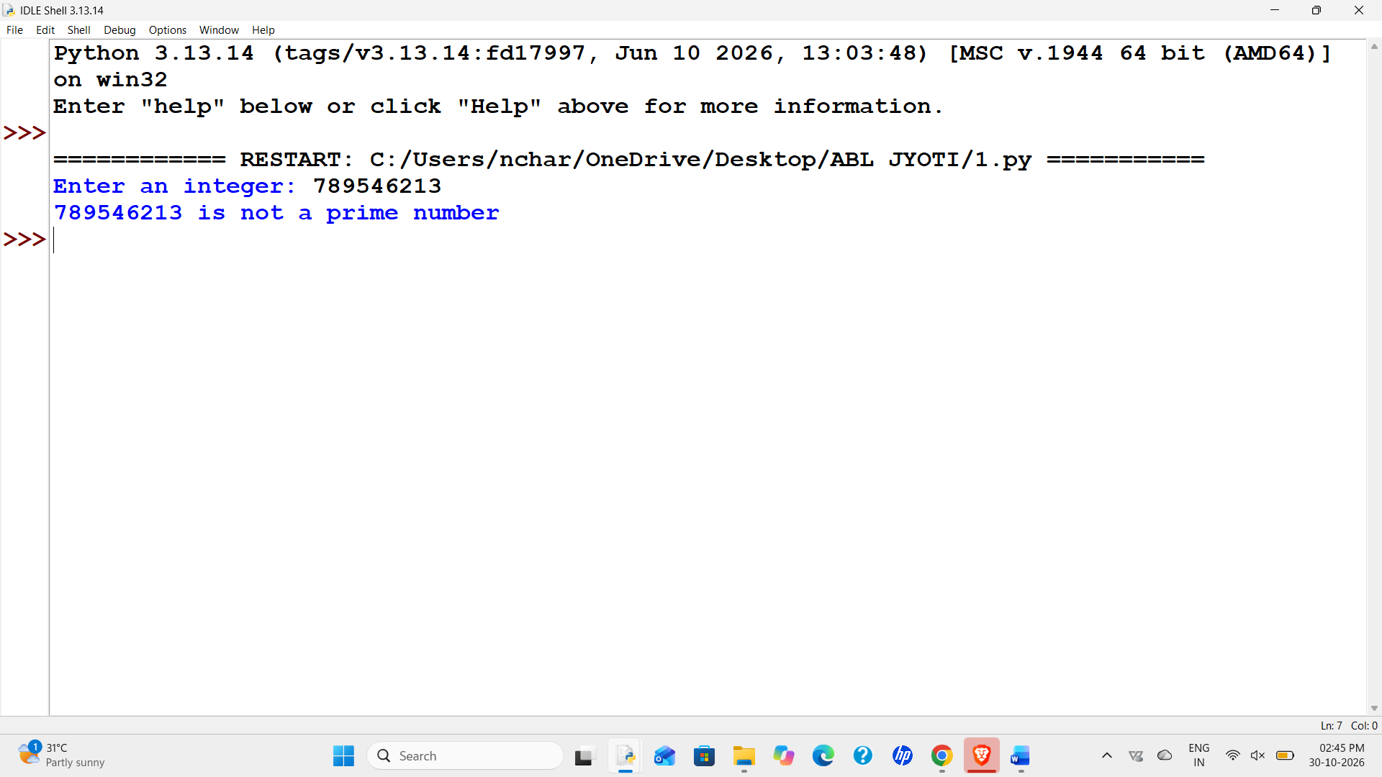
- Conclusion
The program uses a loop and divisibility checks.
Case Study 15: Fibonacci Series Generator
1. Problem Statement
Display the first n terms of the Fibonacci series.

2. Algorithm
- Read the number of terms.
- Start with 0 and 1.
- Repeat n times and display the current term.
- Update the two values each time.

3. Flowchart
Start
|
Read input
|
Process data
|
Display output
|
Stop

4. Pseudocode
START
INPUT required data
PROCESS using conditions / loop
DISPLAY result
STOP

5. Python Source Code
n = int(input("Enter number of terms: ")) if n <= 0:
print("Enter a number greater than zero") else: a = 0 b = 1 for i in range(n): print(a, end=" ") next_term = a + b a = b
b = next_term print()

6. Sample Input and Output
Input: 5
Expected result: 0 1 1 2 3

7. Test Cases
Input: 5 — Expected: 0 1 1 2 3
Input: 1 — Expected: 0
Input: 0 — Expected: Enter a number greater than zero

8.Output Screenshot
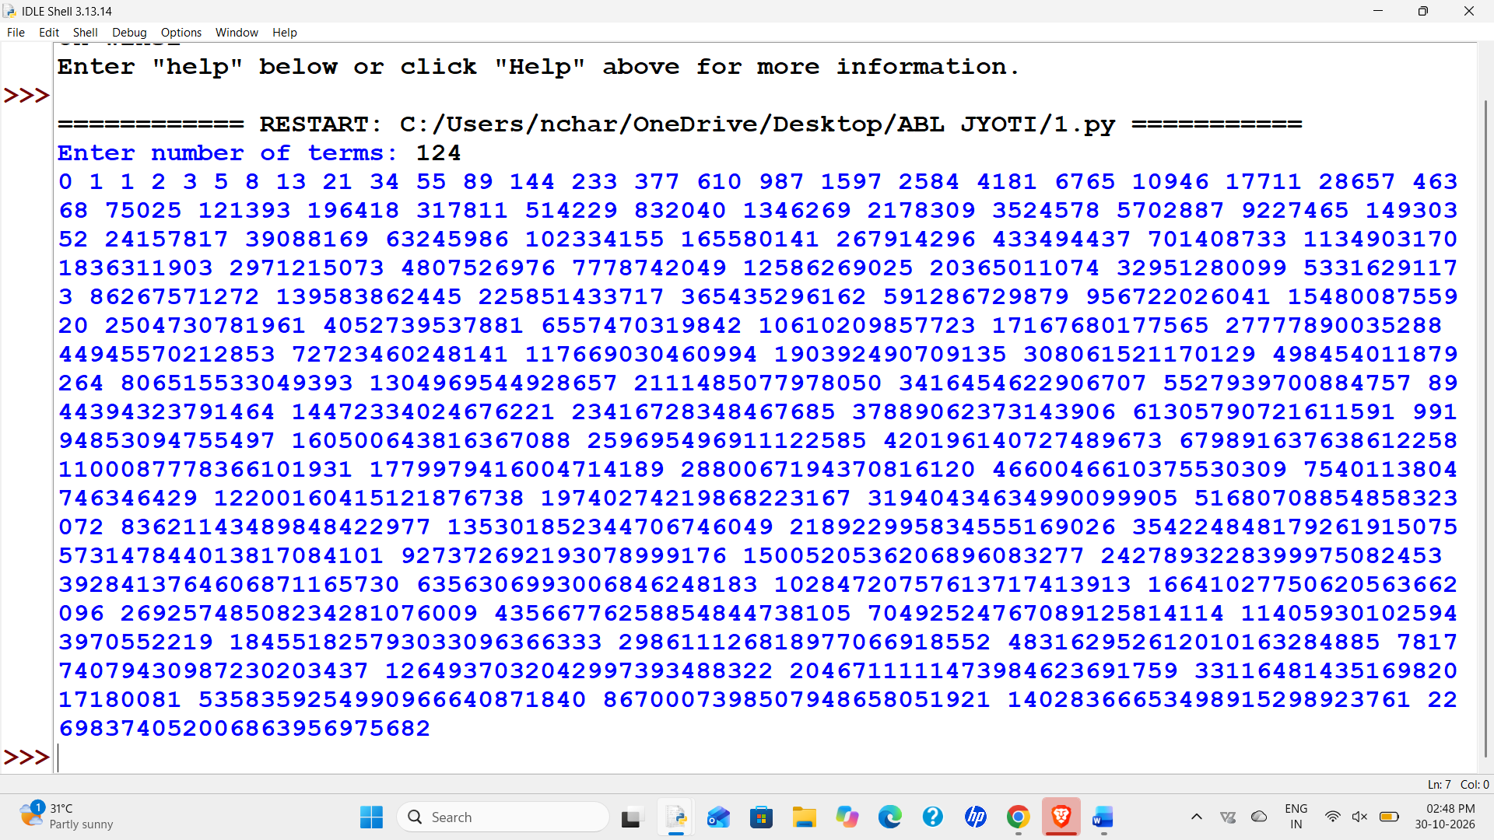
- Conclusion
The program generates Fibonacci numbers using a loop.

Case Study 16: List Statistics Calculator
1. Problem Statement
Read numbers and display the largest, smallest, sum, and average.

2. Algorithm
- Read space-separated numbers.
- Convert them to integers.
- Calculate sum and average.
- Display maximum and minimum values.

3. Flowchart
Start
|
Read input
|
Process data
|
Display output
|
Stop

4. Pseudocode
START
INPUT required data
PROCESS using conditions / loop
DISPLAY result
STOP

5. Python Source Code
values = input("Enter numbers separated by spaces: ").split() if len(values) == 0:
print("No numbers entered") else:
numbers = [] for value in values: numbers.append(int(value)) total = sum(numbers) average = total / len(numbers) print("Largest:", max(numbers)) print("Smallest:", min(numbers)) print("Sum:", total) print("Average:", round(average, 2))

6. Sample Input and Output
Input: 4 8 2 6
Expected result: Largest 8; Smallest 2; Sum 20; Average 5.0

7. Test Cases
Input: 4 8 2 6 — Expected: Largest 8; Smallest 2; Sum 20; Average 5.0
Input: 10 — Expected: Largest 10; Smallest 10; Sum 10; Average 10.0
Input: -2 0 2 — Expected: Largest 2; Smallest -2; Sum 0; Average 0.0
- Output Screenshot
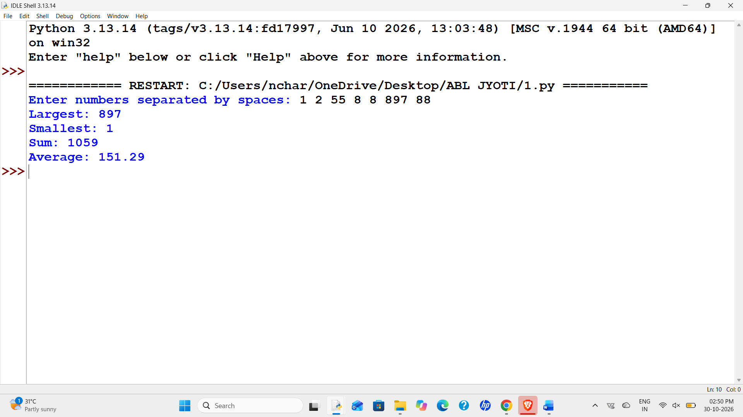
- Conclusion
The program uses lists, loops, and built-in functions.

Case Study 17: Student Grade Report
1. Problem Statement
Read a student's name and three marks, calculate the average, and assign A (90+), B (75+), C (50+), or D.

2. Algorithm
- Read name and three marks.
- Validate marks from 0 to 100.
- Calculate average.
- Use conditions to assign a grade.
- Display the report.

3. Flowchart
Start
|
Read input
|
Process data
|
Display output
|
Stop

4. Pseudocode
START
INPUT required data
PROCESS using conditions / loop
DISPLAY result
STOP

5. Python Source Code
name = input("Enter student name: ") m1 = float(input("Enter mark 1: ")) m2 = float(input("Enter mark 2: ")) m3 = float(input("Enter mark 3: ")) if min(m1, m2, m3) < 0 or max(m1, m2, m3) > 100:
print("Invalid marks") else:
average = (m1 + m2 + m3) / 3 if average >= 90: grade = "A" elif average >= 75: grade = "B" elif average >= 50: grade = "C" else:
grade = "D" print("Student:", name) print("Average:", round(average, 2)) print("Grade:", grade)

6. Sample Input and Output
Input: Ravi: 90,92,88
Expected result: Average 90.0; Grade A

7. Test Cases
Input: Ravi: 90,92,88 — Expected: Average 90.0; Grade A
Input: Maya: 80,75,78 — Expected: Average 77.67; Grade B
Input: Kiran: 40,45,35 — Expected: Average 40.0; Grade D
- Output Screenshot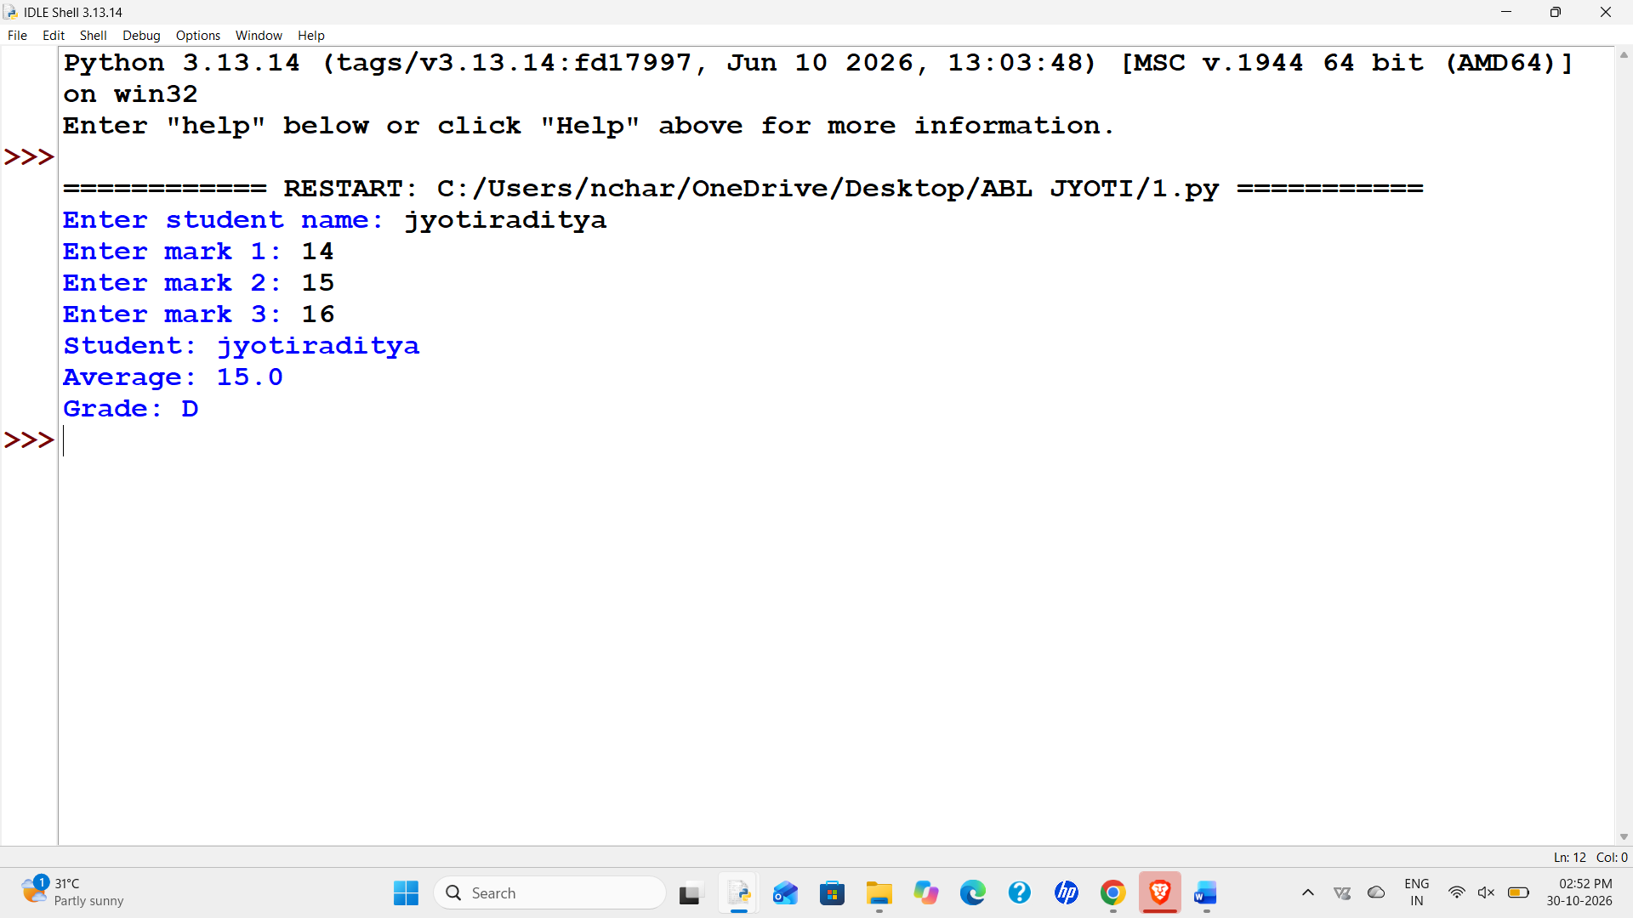
- Conclusion
The program combines input, validation, arithmetic, and conditions.
Case Study 18: Vowel and Consonant Counter
1. Problem Statement
Count vowels and consonants in text, ignoring spaces, digits, and punctuation.

2. Algorithm
- Read text and convert it to lowercase.
- Visit each character.
- Count alphabetic characters as vowels or consonants.
- Display both counts.

3. Flowchart
Start
|
Read input
|
Process data
|
Display output
|
Stop

4. Pseudocode
START
INPUT required data
PROCESS using conditions / loop
DISPLAY result
STOP

5. Python Source Code
text = input("Enter a word or sentence: ").lower() vowels = 0 consonants = 0 for ch in text: if ch.isalpha(): if ch in "aeiou":
vowels = vowels + 1 else:
consonants = consonants + 1 print("Vowels:", vowels) print("Consonants:", consonants)

6. Sample Input and Output
Input: Hello
Expected result: Vowels 2; Consonants 3

7. Test Cases
Input: Hello — Expected: Vowels 2; Consonants 3
Input: AI Lab 2026 — Expected: Vowels 3; Consonants 2
Input: 123 ! — Expected: Vowels 0; Consonants 0
- Output Screenshot
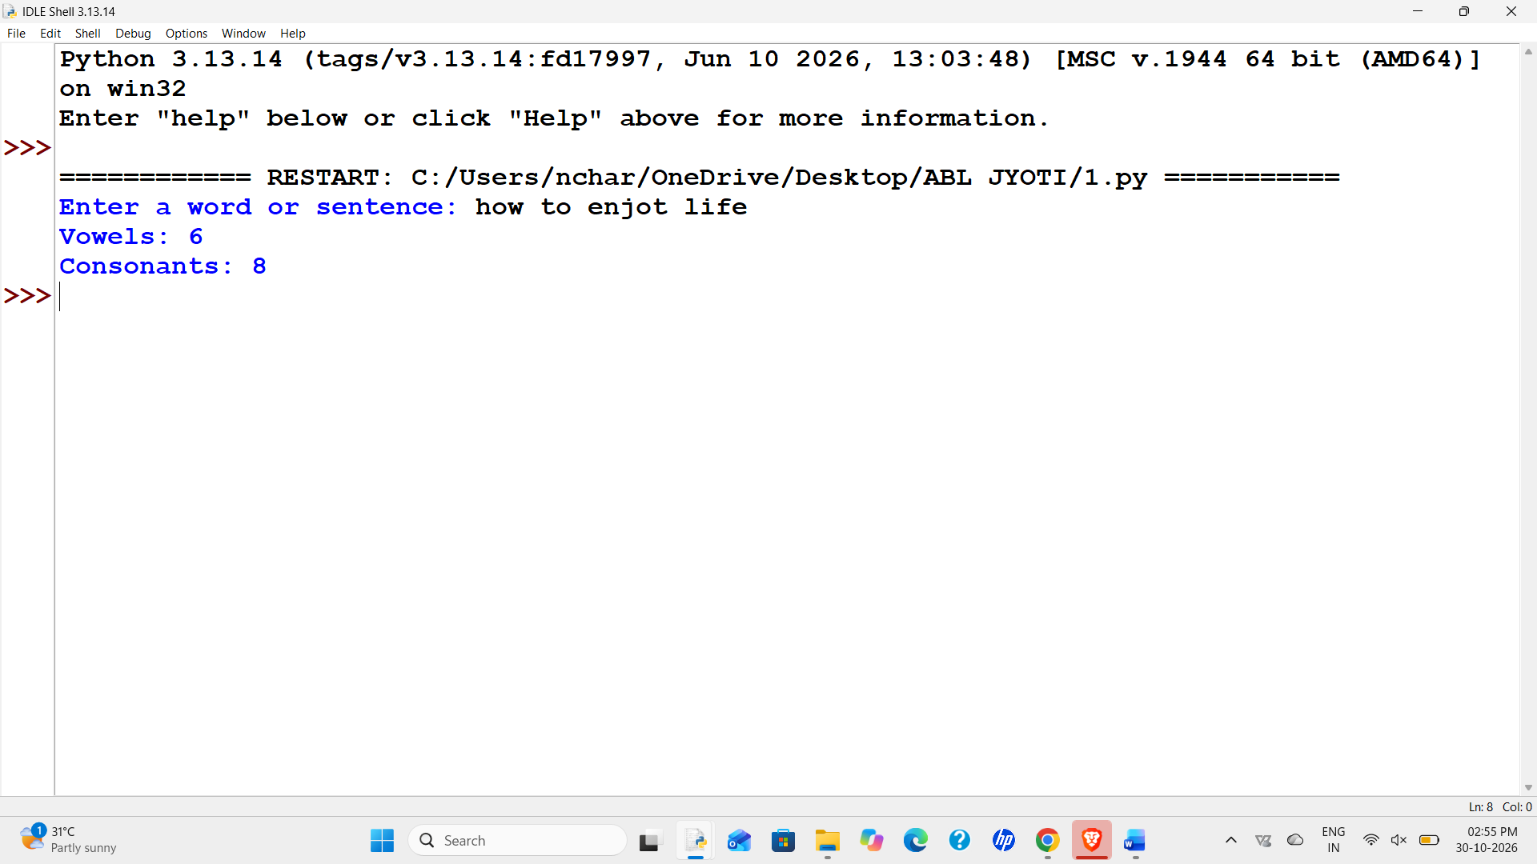
- Conclusion
The program practices strings, loops, and counters.

Case Study 19: Multiplication Table Printer
1. Problem Statement
Print the multiplication table of a number from 1 to 10.

2. Algorithm
- Read a number.
- Loop from 1 to 10.
- Multiply the number by the counter.
- Display each result.

3. Flowchart
Start
|
Read input
|
Process data
|
Display output
|
Stop

4. Pseudocode
START
INPUT required data
PROCESS using conditions / loop
DISPLAY result
STOP

5. Python Source Code
n = int(input("Enter a number: ")) for i in range(1, 11): print(n, "x", i, "=", n * i)

6. Sample Input and Output
Input: 5
Expected result: 5 x 1 = 5 ... 5 x 10 = 50

7. Test Cases
Input: 5 — Expected: 5 x 1 = 5 ... 5 x 10 = 50
Input: 0 — Expected: All results are 0
Input: -2 — Expected: -2 x 10 = -20
- Output Screenshot
[Paste a genuine screenshot from Python IDLE or terminal here.] 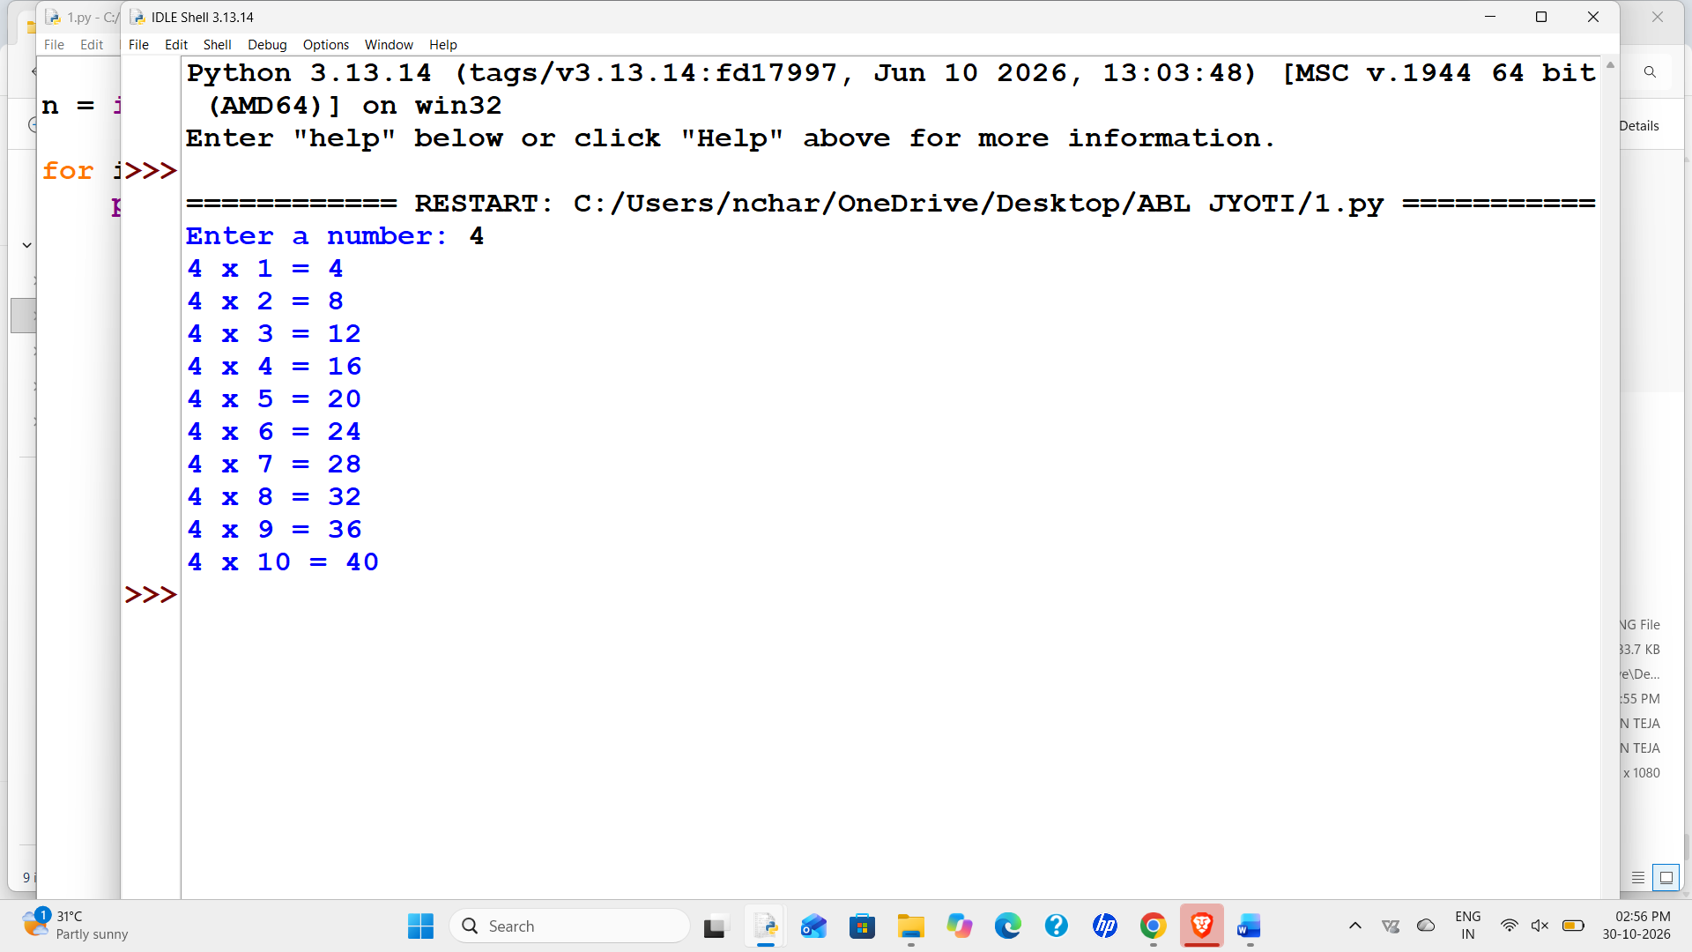
- Conclusion
The program uses a for loop for repeated multiplication.

Case Study 20: Bank Account Menu Program
1. Problem Statement
Create a menu for checking balance, depositing, withdrawing, and exiting. Start with 1000.

2. Algorithm
- Set balance to 1000.
- Display a menu in a loop.
- Check the user's choice.
- Validate deposit and withdrawal amounts.
- Exit when selected.

3. Flowchart
Start
|
Read input
|
Process data
|
Display output
|
Stop

4. Pseudocode
START
INPUT required data
PROCESS using conditions / loop
DISPLAY result
STOP

5. Python Source Code
balance = 1000 while True:
print("\n1. Check Balance") print("2. Deposit") print("3. Withdraw") print("4. Exit") choice = input("Enter your choice: ") if choice == "1":
print("Balance: Rs.", balance) elif choice == "2":
amount = float(input("Enter deposit amount: ")) if amount > 0:
balance = balance + amount print("Deposit successful") else:
print("Invalid amount") elif choice == "3":
amount = float(input("Enter withdrawal amount: ")) if amount > 0 and amount <= balance: balance = balance - amount print("Withdrawal successful") else:
print("Invalid amount or insufficient balance") elif choice == "4": print("Thank you") break else: print("Invalid choice")

6. Sample Input and Output
Input: Choice 1
Expected result: Balance: Rs. 1000

7. Test Cases
Input: Choice 1 — Expected: Balance: Rs. 1000
Input: Deposit 500 — Expected: Balance becomes Rs. 1500
Input: Withdraw 2000 — Expected: Invalid amount or insufficient balance
8. Output Screenshot
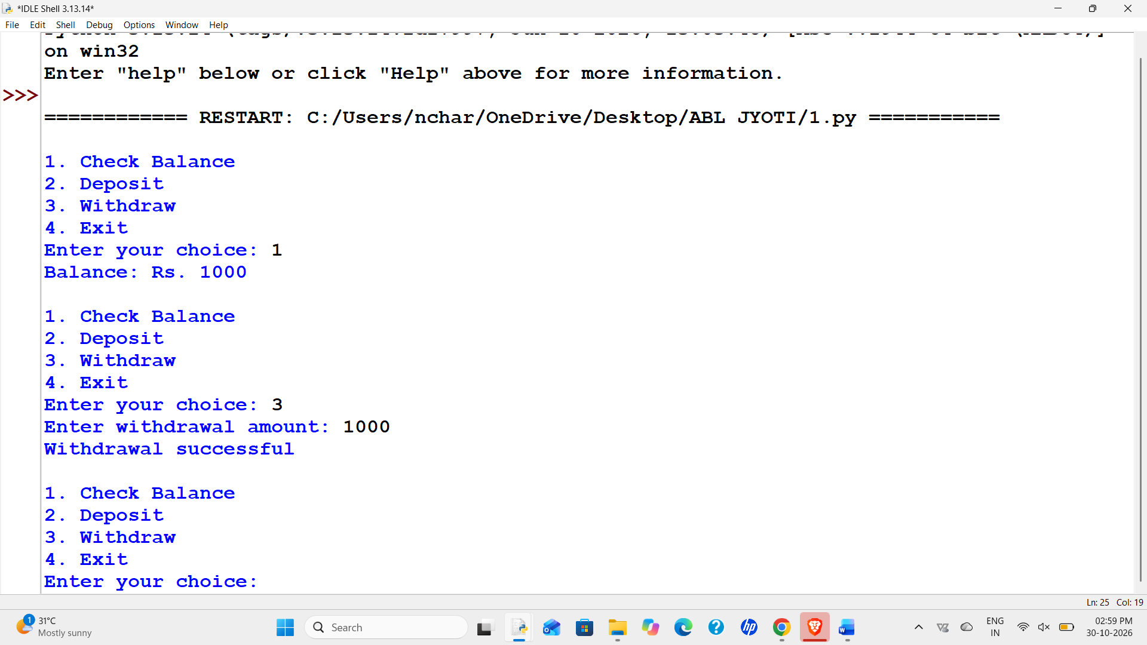

9. Conclusion
The program demonstrates menus, loops, conditions, and balance updates.

